








































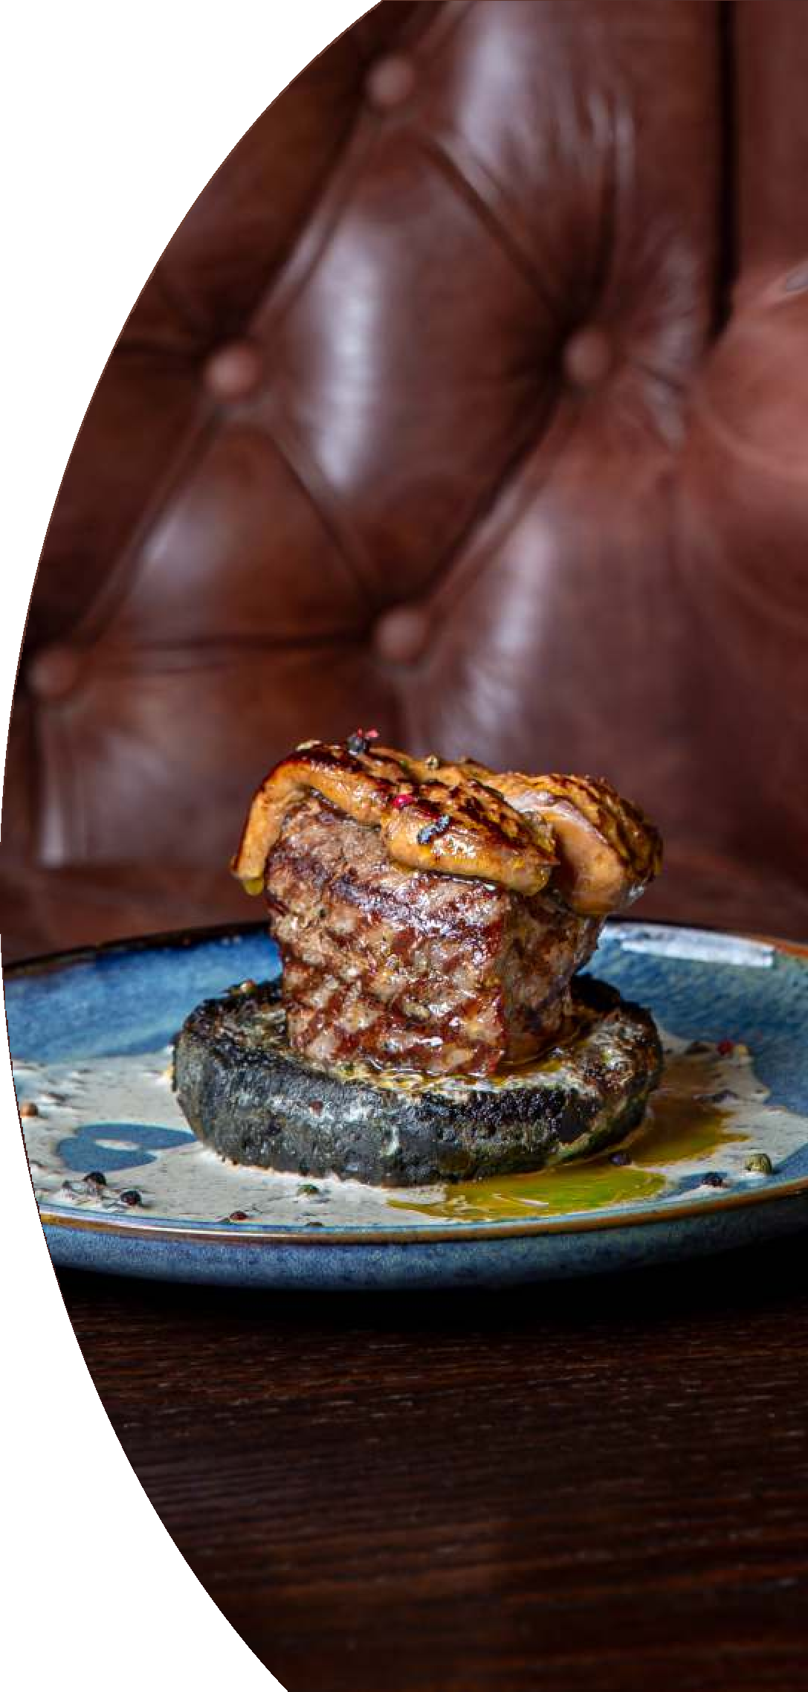
















APPETIZER OF THE NIGHT
GUSTĂRILE NOPȚII

390 gr 380 lei

250 gr 220 lei





BEER APPETIZERS

GUSTĂRI LA BERE

100 gr 145 lei

100 gr 145 lei

100 gr 145 lei

100 gr 145 lei

100 gr 100 lei

150 gr 110 lei


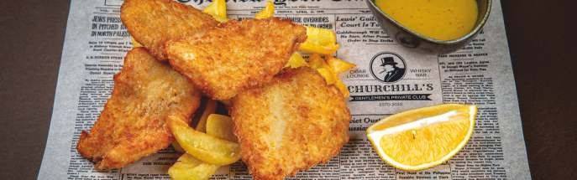
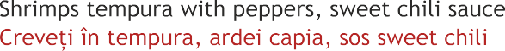




230 gr 145 lei

260 gr 145 lei

180/50 gr 145 lei 200/100/30 gr 265 lei
240/50 gr 245 lei

80/50/30 gr 140 lei 170/50/30 gr 175 lei 150/30 gr 110 lei 160 gr 90 lei
100 gr 110 lei

100 gr 120 lei


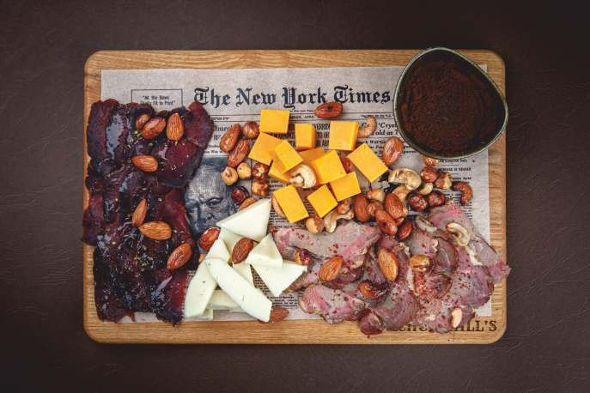
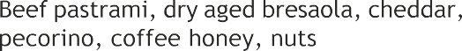


280 gr 390 lei

280 gr 290 lei

1/200/100/160/260 gr 570 lei

300 gr 360 lei


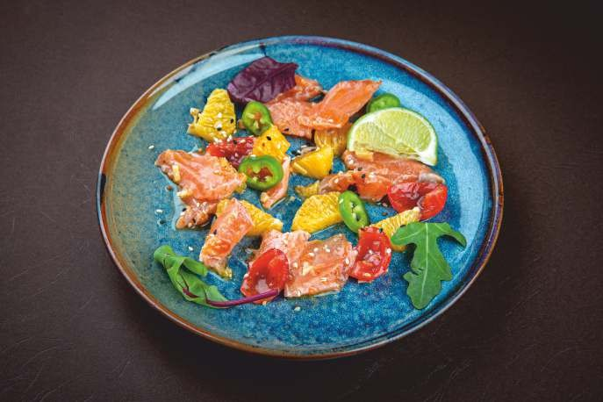




AMAZING APPETIZERS APERITIVE EXTRAORDINARE
FISH/PEÇTE

170 gr 210 lei

170 gr 240 lei

180 gr 245 lei

250 gr 220 lei


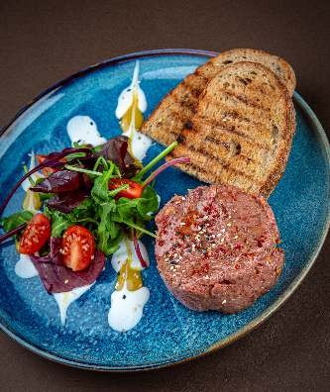
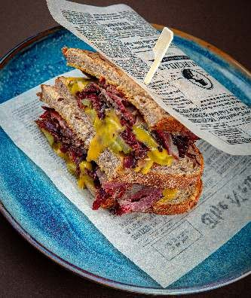

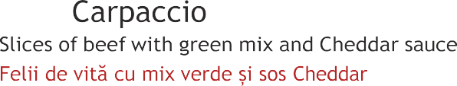




MEAT/CARNE

250 gr 220 lei

250 gr 220 lei

170 gr 240 lei

170/70 gr 230 lei

130 gr 245 lei

150/50/30 gr 165 lei


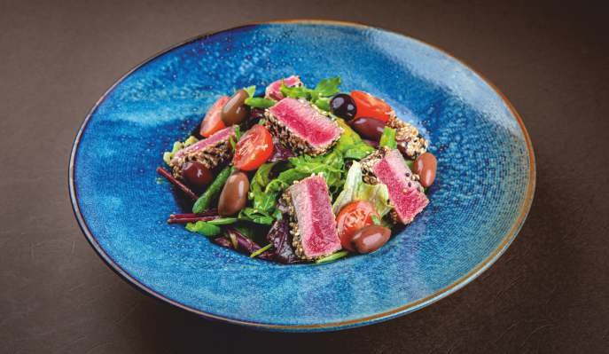


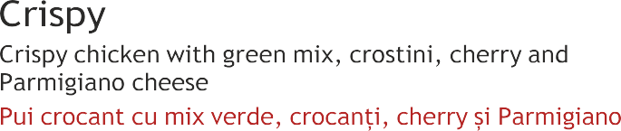



SALADS/SALATE

170 gr 125 lei

270 gr 230 lei

280 gr 235 lei

280 gr 165 lei

280 gr 185 lei

180 gr 165 lei

320 gr 175 lei


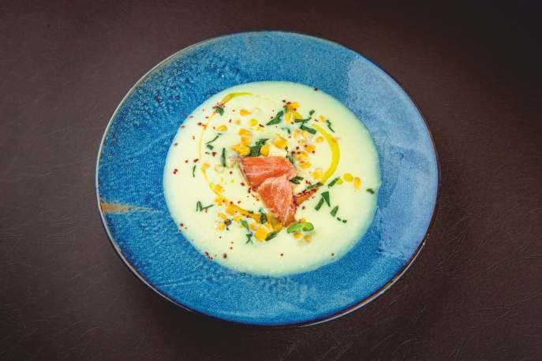
SOUPS/SUPE

310 gr 90 lei

300 gr 125 lei

300 gr 175 lei

350 gr 125 lei

MAIN COURSE/FEL PRINCIPAL BEEF/VITĂ

1/350/120/30 gr 240 lei

1/350/120/30 gr 450 lei

100 gr 160 lei

320 gr 390 lei

260 gr 165 lei

Slow-cooked beef for 6 hours with Mexican dried chili and a traditional spice blend, yielding a silky texture and a deep aromatic consommé designed for immersive tasting
Vită gătită lent timp de 6 ore cu ardei iute mexican uscat și un amestec
260 gr 220 lei



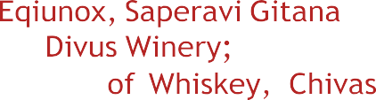
tradițional de condimente, rezultând o textură mătăsoasă și un consommé aromatic intens, conceput pentru o degustare captivantă
450 gr 1350 lei

100 gr 245 lei

100 gr 190 lei

280 gr 270 lei


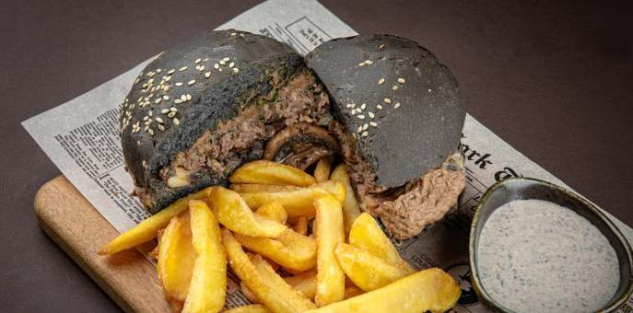
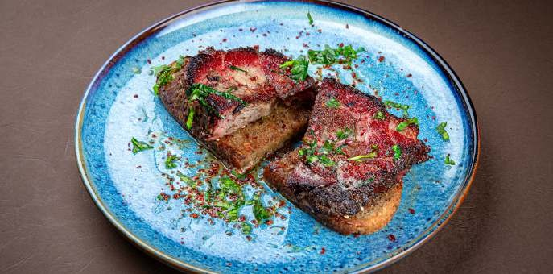
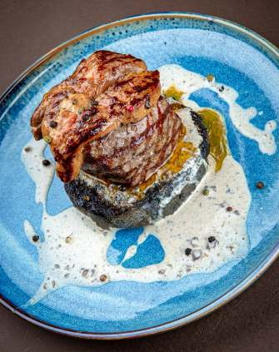
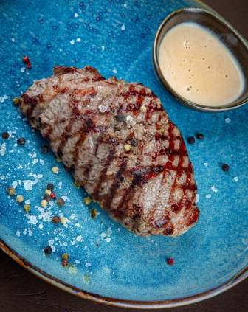

POULTRY/PASARE

260 gr 225 lei


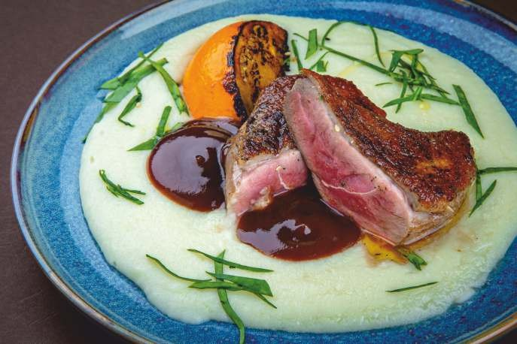




XL 260/50/50 gr 165 lei XXL 500/100/100 gr 265 lei

390 gr 185 lei
Shredded chicken prepared in a tomato-chipotle sauce, offering smoky undertones and balanced juiciness that elevates this classic flavor
Pui mărunțit preparat într-un sos de roșii și chipotle, oferind note afumate și o suculență echilibrată care sporește această aromă clasică
200/250 gr 370 lei


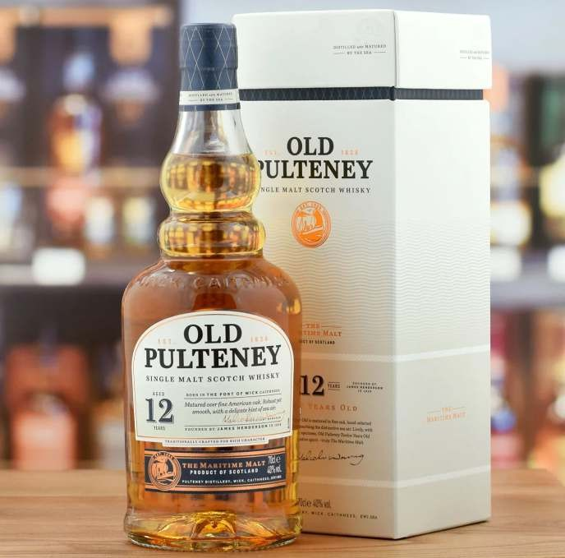

PORK/PORC

240/100/70 gr 290 lei

240 gr 165 lei
Pork neck confit at low temperature to achieve a tender, velvety texture and a profound flavor that honors traditional slow cooking
Ceafă de porc confiată la temperatură scăzută pentru a obține o textură moale și catifelată și o aromă profundă care onorează gătitul lent tradițional

FISH & SEAFOOD/PEÇTE & FRUCTE DE MARE
260 gr 320 lei

260 gr 320 lei

650 gr 560 lei

280 gr 290 lei

Butter-sautéed shrimp paired with gratin melted cheese and sauce
200 gr 240 lei


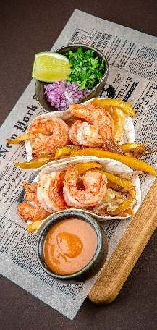
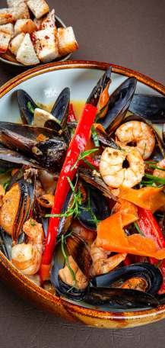
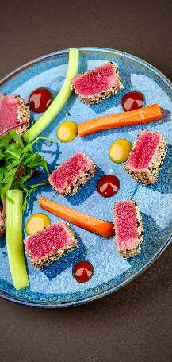


chipotle, set over a lightly crisped tortilla for a rich and harmonious bite
Creveți sotați în unt, combinați cu brânză topită gratinată și sos chipotle, așezați peste o tortilla ușor crocantă, pentru o gustare bogată și armonioasă


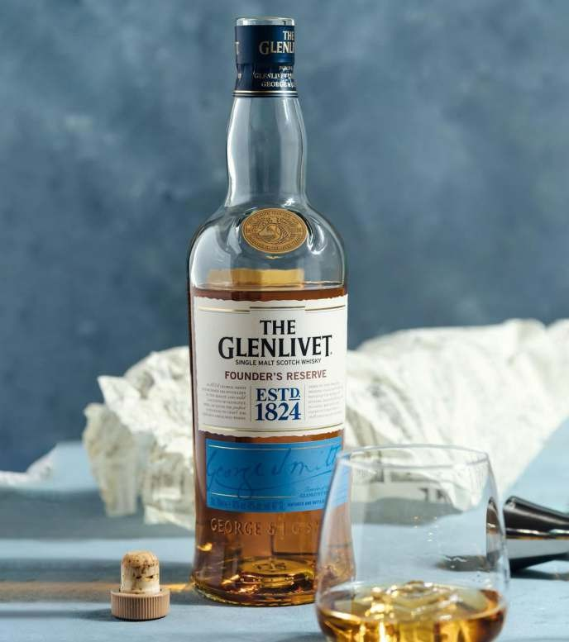
Special Gourmet Dinner by W.Churchill 1200 lei
Glass of Champagne Cupa de sampanie

Chicken liver Pate Pate din ficat de pui

Grilled 300gr Fillet mignon medium & Blue cheese sauce with green salad 300 gr Fillet mignon grilat medium & sos Blue cheese cu salata verde

Double whisky Glenlivet

DESSERT/DESERT

Avocado taken to its finest version: airy, creamy, and fresh.

150 gr 160 lei

130 gr 160 lei





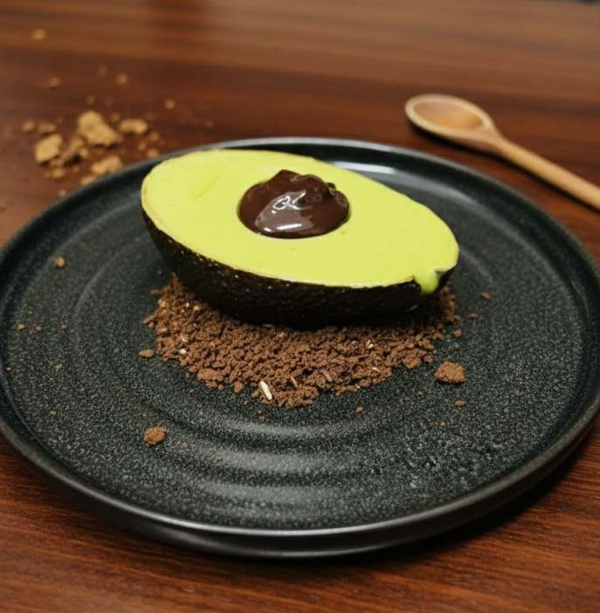
A play of texture and flavor that can't be explained… it has to be tasted.
Avocado dus la cea mai bună versiune: aerisit, cremos și proaspăt. Un joc de textură și aromă care nu poate fi explicat... trebuie gustat.


BAR MENU
Coffee lei
Espresso. 45
Espresso Doppio. 60
Americano. 45
Cappuccino. 55
Latte. 55
Flat White. 70
Tea lei
Ceai cu ghimbir 85
Ceai din zmeură 85
Ceai din catină 85
Ceai în asortiment. 60
Limonade 400ml lei
Limonada Classică. 100
Limonada cu ghimbir 100
Limonada din zmeură. 100
Limonada fructul pasiunii. 120
Limonada măr cu aloe. 120

Water lei
Plată/gazată. . . . . . . . . . . . . . . . . . . . . . . . . . . . . . . . . . . . . . . . . . . . . . . . . . . . . . . . . . . 0.33. 50
Plată/gazată. . . . . . . . . . . . . . . . . . . . . . . . . . . . . . . . . . . . . . . . . . . . . . . . . . . . . . . . . . . .0.75. 70
Coca-Cola/Coca-Cola Zero. . . . . . . . . . . . . . . . . . . . . . . . . . . . . . . . . . . . . . . . . . . . . 0.25. 50
Fanta/Sprite/Schweppes. . . . . . . . . . . . . . . . . . . . . . . . . . . . . . . . . . . . . . . . . . . . . . . . .0.25. 50
Borjomi. . . . . . . . . . . . . . . . . . . . . . . . . . . . . . . . . . . . . . . . . . . . . . . . . . . . . . . . . . . . . . . . .0.5. 80

Juice lei
Fresh portocala. . . . . . . . . . . . . . . . . . . . . . . . . . . . . . . . . . . . . . . . . . . . . . . . . . . . . . 200ml. 100
Fresh grapefruit. . . . . . . . . . . . . . . . . . . . . . . . . . . . . . . . . . . . . . . . . . . . . . . . . . . . . . 200ml. 100
Suc în asortiment. . . . . . . . . . . . . . . . . . . . . . . . . . . . . . . . . . . . . . . . . . . . . . . . . . . . .250ml. 60

Draft Beer lei
Churchill's Lager. . . . . . . . . . . . . . . . . . . . . . . . . . . . . . . . . . . . . . . . . . . . . . . . . . . 0,33/0,5. . . 55/75
Holz Belgian Blonde. . . . . . . . . . . . . . . . . . . . . . . . . . . . . . . . . . . . . . . . . . . . . . . .0,33/0,5. . . 55/75
Holz IPA. . . . . . . . . . . . . . . . . . . . . . . . . . . . . . . . . . . . . . . . . . . . . . . . . . . . . . . . . . . 0,33/0,5. . .65/80
Seasonal beer. . . . . . . . . . . . . . . . . . . . . . . . . . . . . . . . . . . . . . . . . . . . . . . . . . . . . . . . . . . . . . . . . . . . . .

Bottled Beer lei
Corona Extra. . . . . . . . . . . . . . . . . . . . . . . . . . . . . . . . . . . . . . . . . . . . . . . . . . . . . . . . . . . 0,35. 100
Guinness Dark. . . . . . . . . . . . . . . . . . . . . . . . . . . . . . . . . . . . . . . . . . . . . . . . . . . . . . . . . .0,44. 120
Holz Alkoholfrei. . . . . . . . . . . . . . . . . . . . . . . . . . . . . . . . . . . . . . . . . . . . . . . . . . . . . . . . 0,30. 70

Wine
Red
lei


Nocturne Rara Neagra de Purcari. . . . . . . . . . . . . . . . . . . . . . . . . . . . . . . . . . . . . . . . .750. 600
Nocturne Cabernet Sauvignon de Purcari. . . . . . . . . . . . . . . . . . . . . . . . .150/750 110/500
Limited Saperavi de Purcari. . . . . . . . . . . . . . . . . . . . . . . . . . . . . . . . . . . . . . . . . . . .750. 550
Rosu de Purcari . . . . . . . . . . . . . . . . . . . . . . . . . . . . . . . . . . . . . . . . . . . . . . . . . . . . . . 750. 800
Negru de Purcari. . . . . . . . . . . . . . . . . . . . . . . . . . . . . . . . . . . . . . . . . . . . . . . . . . . . . .750. 1050
Carpe Diem Bad Boys. . . . . . . . . . . . . . . . . . . . . . . . . . . . . . . . . . . . . . . . . . . . . . . . . 750 950
Divus Winery Endemic. . . . . . . . . . . . . . . . . . . . . . . . . . . . . . . . . . . . . . . . . . . . . . . . .750. 500
Equinox 5 Elementr . . . . . . . . . . . . . . . . . . . . . . . . . . . . . . . . . . . . . . . . . . . . . . . . . . . 750. 950
Equinox Shiraz. . . . . . . . . . . . . . . . . . . . . . . . . . . . . . . . . . . . . . . . . . . . . . . . . . . . . . . 750. 800
Gitana Wineri Lupi. . . . . . . . . . . . . . . . . . . . . . . . . . . . . . . . . . . . . . . . . . . . . . . . . . . . .750 1100
Gitana Winery Saperavi. . . . . . . . . . . . . . . . . . . . . . . . . . . . . . . . . . . . . . . . . . . . . . . . 750. 1000
Novak Syarh Copceac. . . . . . . . . . . . . . . . . . . . . . . . . . . . . . . . . . . . . . . . . . . . . . . . . 750. 600
Te Wa Wines Malbec . . . . . . . . . . . . . . . . . . . . . . . . . . . . . . . . . . . . . . . . . . . . . . . . . . 750 650
Vinaria Nobila Cabernet Franc. . . . . . . . . . . . . . . . . . . . . . . . . . . . . . . . . . . . . . . . . .750. 800
Snob Cabernet Sauvignon/Merlot/Saperavi . . . . . . . . . . . . . . . . . . .150/750 90/400
Rose
Nocturne Rose de Purcari. . . . . . . . . . . . . . . . . . . . . . . . . . . . . . . . . . . . . . . 150/750. 110/500
Snob Merlot/Pinot Noir. . . . . . . . . . . . . . . . . . . . . . . . . . . . . . . . . . . . .150/750 90/400
White
Nocturne Pinot Grigio de Purcari. . . . . . . . . . . . . . . . . . . . . . . . . . . . . . . . . 150/750. 110/500
Nocturne Viorica de Purcari. . . . . . . . . . . . . . . . . . . . . . . . . . . . . . . . . . . .150/750. 110/500
Alb de Purcari. . . . . . . . . . . . . . . . . . . . . . . . . . . . . . . . . . . . . . . . . . . . . . . . . . . . . . . . 750. 800
Divus Winery Ornis. . . . . . . . . . . . . . . . . . . . . . . . . . . . . . . . . . . . . . . . . . . . . . . . . . . .750. 500
Domeniile Vorniceni Trei Mandre. . . . . . . . . . . . . . . . . . . . . . . . . . . . . . . . . . . . . . . 750. 420
Novak 500 Alb de Onitcani. . . . . . . . . . . . . . . . . . . . . . . . . . . . . . . . . . . . . . . . . . . . .750. 550
Vinaria Nobila Chardonnay. . . . . . . . . . . . . . . . . . . . . . . . . . . . . . . . . . . . . . . . . . . . .750. 550
Snob Sauvignon. . . . . . . . . . . . . . . . . . . . . . . . . . . . . . . . . . . . . . . . .150/750 90/370
Snob Viorica/Chardonnay. . . . . . . . . . . . . . . . . . . . . . . . . . . . . . . .150/750 90/370
Sparkling lei
Snob Brut White. . . . . . . . . . . . . . . . . . . . . . . . . . . . . . . . . . . . . . . . . . . . . . . . . . 750 400
Novak 4 Soiuri. . . . . . . . . . . . . . . . . . . . . . . . . . . . . . . . . . . . . . . . . . . . . . . . . . . . . . . . . . 750. 450
Cuvee de Purcari Brut White. . . . . . . . . . . . . . . . . . . . . . . . . . . . . . . . . . . . . . . . . . . 750. 620
Cuvee de Purcari Brut Rose . . . . . . . . . . . . . . . . . . . . . . . . . . . . . . . . . . . . . . . . . . . .750. 620
Wine Crime Flirty Sparkling Rose. . . . . . . . . . . . . . . . . . . . . . . . . . . . . . . . . . . . . . . 750. 350
Wine Crime Naughty Sparkling. . . . . . . . . . . . . . . . . . . . . . . . . . . . . . . . . . . . . . . . . 750 350
Domeniile Vorniceni Spumant. . . . . . . . . . . . . . . . . . . . . . . . . . . . . . . . . . . . . . . . . .750. 400
Giusti Asolo Prosecco Extra Brut. . . . . . . . . . . . . . . . . . . . . . . . . . . . . . . . . . . . . . . .750. 600
Giusti Asolo Prosecco Brut . . . . . . . . . . . . . . . . . . . . . . . . . . . . . . . . . . . . . . . . . . . . 750. 600
Moet&Chandon. . . . . . . . . . . . . . . . . . . . . . . . . . . . . . . . . . . . . . . . . . . . . . . . . . . . . . 750 3500
Pago de Tharsys Cava Brut . . . . . . . . . . . . . . . . . . . . . . . . . . . . . . . . . . . . . . . . . . . .750. 480
Pago de Tharsys Cava Brut Nature . . . . . . . . . . . . . . . . . . . . . . . . . . . . . . . . . . . . . 750. 480

Rum 40ml lei
Havana Club 3 Y.O 90
Havana Club 7 Y.O 1 40
Bacardi Carta Blanca. 80
Bacardi Gold. 80
Bacardi Carta Negra. 80
Bacardi Spiced. 80
Bacardi Reserva Ocho & Years. 130
Captain Morgan Black. 90
Captain Morgan Spiced Gold. 90
Captain Morgan White. 90
Diplomatico Reserva Exclusiva. 240
Don Papa. 300


El Dorado 12 Years. 220
Pyrat XO Reserve. 150
Plantation Black Cask. 110
Plantation Gran Anejo. 120
Plantation 20th Anniversary 230
Progresiva 200
Angostura 3 Y.O 70
Angostura 5 Y.O 90
Angostura Premium 7 Y.O 130
Angostura Premium 1919 170
Angostura Premium 1824 12 Y.O 180

Gin 40ml lei
Bombay 85
Citadelle Rouge. 100
East 135 140
Hendrick's 120

Tequila 40ml lei
Jose Cuervo Silver 90
Jose Cuervo Reposado. 90
Olmeca Silver 100
Olmeca Gold. 100

Vermouth 80ml lei
Martini Bianco. 90
Martini Rosso. 90
Martini Rosato. 90
Martini Extra Dry 90
Divin 40ml lei
Bardar Gold 10 ani. 100
Bardar Gold 12 ani. 120
Bardar Platinum 20 ani. 420
Bardar Platinum 25 ani 620
Curchill's 15 ani 270
Churchill's 20 ani 370

Cognac 40ml lei
Pierre Ferrand 1840. 160
Pierre Ferrand 10 Generations. 170
Hennessy V.S. 150
Hennessy V.S.O.P 220
Hennessy X.O 500
Martell V.S. 160
Martell V.S.O.P 220

Brandy 40ml lei
Ararat 3 Y.O 100
Ararat 5 Y.O 120
Ararat 7 Y.O. Otborny 140
Ararat 10 Y.O. Akhtamar 150
Ararat 20 Y.O. Nairi. 500

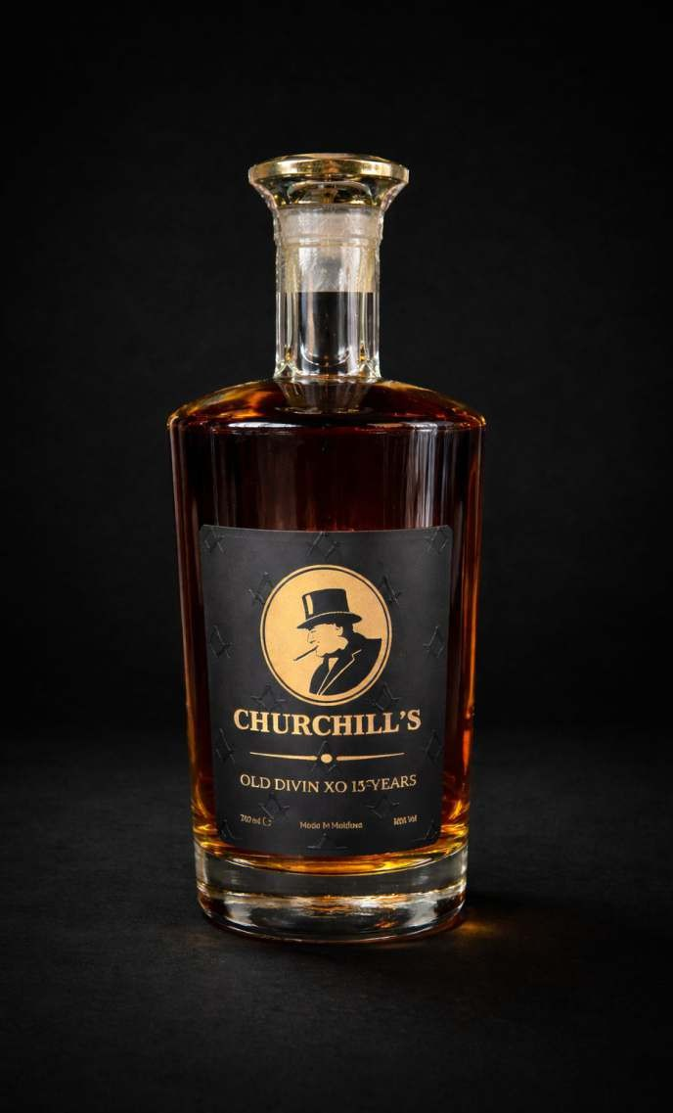


Vodka 40ml lei
Absolut 90
Nemiroff Lex. 110
Belvedere. 120
Grey Goose. 140

Liqueur 40ml lei
Bailey's 70
Aperol. 70
Campari. 70
Jagermeister 90
Kahlua 70
Sambuca. 80
Tatratea. 90
Absinth 40ml lei
Tunnel Green. 90
Cocktails lei
Whisky Sour 130
Manhattan. 120
Creme Brule Sour 120
Almond Whiskey 120
New York Sour 120
Gin-Tonic. 130
Clover Club. 120
Aperol Spritz. 120
Old fashioned by Churchill's 150
Holly water 1 40
Sazerac 220
Negroni 130
Long Island 150
Bloody Mary 120
Cosmopolitan 135
Espresso Martini. 120
White Russian. 130
Sofia. 180

Shot lei
B52. 110
B53. 120
Green Mexican. 110
Hirosima. 140

Irish Whiskey 40ml lei
Jameson Stout Edition. 120
Jameson Black Barrel. 170
Redbreast 12 Y.O 180
The Pogues. 90
The Pogues Streams of Whiskey 90
Tullamore Dew 80


Tullamore Dew 12 Y.O 130
Teeling Small Batch. 120
Teeling Single Grain. 1 40
Teeling Single Pot Still. 140
Teeling Single Malt. 170
Teeling Small Batch Stiggins Pineapple Rum Cask. 170
Teeling Blackpitts Single Malt. 180
Scotch Whisky 40 ml lei
An Cnoc 12 Y.O 170
Aberlour 12 Y.O 200
Ardbeg 10 Y.O 230
Ballantine's Finest. 80
Ballantine's Burbon Finish 7 Y.O 90
Bankhall Single Malt. 90
Black Bottle Original. 110
Black Bottle Captain Cask. 120
Bunnahabhain Stiuireadair 120
Bunnahabhain Toiteach a Dha. 200
Bunnahabhain 12 Y.O 220
Bruichladdich Laddie. 280
Clan Macgregor 80
Chivas Regal 12 Y.O 1 40
Chivas Regal Extra. 200
Chivas Regal XV 230
Chivas Regal 18 Y.O 240
Chivas Regal Ultis. 530
Chivas Royal Salute 21 Y.O 700
Churchill's Single Malt 160
Dewar's 12 Years. 160
Deanston Kentucky Oak. 120
Deanston Virgin Oak. 130
Famous Grouse. 90
Famous Grouse Smoky Bland. 120
Glenfiddich 12 Y.O 220
Glenfiddich 15 Y.O 250
Glenfiddich 18 Y.O 620
Glenmorangie Original 10 Y.O 150
Glenmorangie Lasanta 12 Y.O 200
Glenmorangie Quinta Ruban 14 Y.O 200
Glenmorangie Nectar 16 Y.O 2 40
J&B Rare. 90
Jura 10 Y.O 200
Jura 12 Y.O 220
Johnnie Walker Red Label. 90
Johnnie Walker Black Label 12 Y 130
Johnnie Walker Gold Label Reserve. 210
Johnnie Walker Blue Label. 900
Lagavulin 8 Years. 2 40
Lagavulin 16 Years. 380
Laphroaig Quartea Cask. 2 40
Monkey Shoulder 130
Mossburn Blended Malt. 2 40
Mossburn Speyside 180
Old Pulteney 12 Y.O 180
Talisker Storm 200

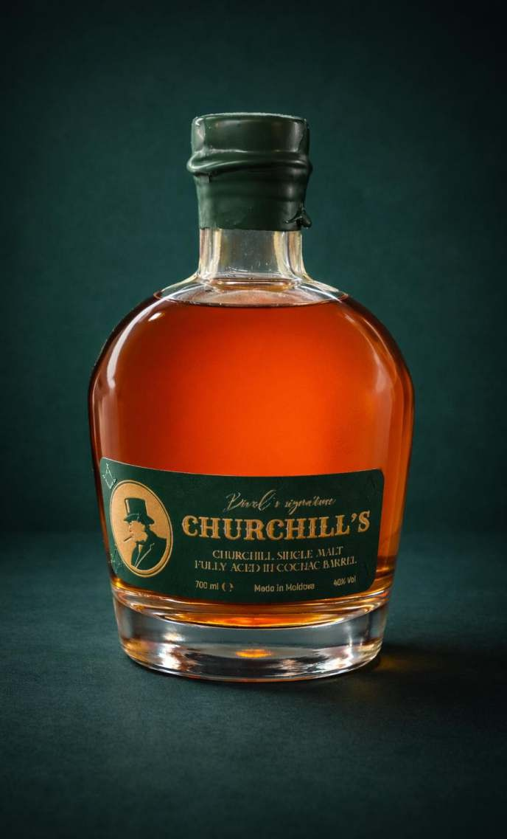

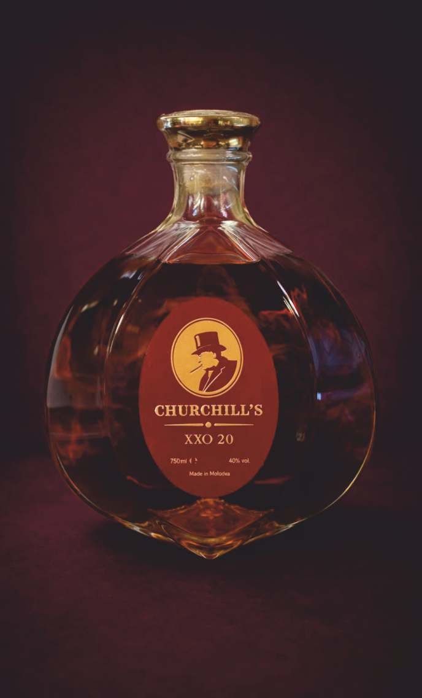


The Dalmore 12 Y.O 160
The Glenlivet. 170
The Macallan 12 Y.O 270
The Macallan 15 Y.O 500
The Macallan 18 Y.O 1100
The Macallan Rare Cask. 1000
The Singleton 12 Y.O 170
Tobermory 12 Year 210
Torabhaig Allt Gleann. 260
Torabhaig Cnoc Na Moine. 320
Tamnavulin Sherry Cask. 150
Tamnavulin Double Cask. 150
Bourbon 40ml lei
Evan Williams Black Label. 80
Evan Williams Single Barrel. 170
Elijah Craig Small Batch. 150
Buffalo Trace. 120
Bulleit. 160
Four Roses. 160
Gentleman Jack. 130
Jack Daniel's. 100
Jack Daniel's Single Barrel. 160
Jim Beam. 100
Marker's Mark. 160
Rittenhouse Reye. 140
Wild Turkey 100
Wild Turkey 101 Proof 120
Japanese Whisky 40ml lei
Fuyu. 140
Fujimi. 150
Hatozaki Finest Blend. 160
Hatozaki SBPure Malt. 220
Kamiki Blended Malt. 220
Kamiki Intense. 220
Kamiki Sakura Wood. 220
Kurayoshi. 250
Kurayoshi 12 Y.O 400

Whisky/Rum tasting
Churchill's I. 3 types of Whisky/Rum with appetizer
Churchill's I. 3 tipuri de Whisky/Rum cu gustare

Churchill's II. 5 types of Whisky/Rum with appetizer
Churchill's II. 5 tipuri de Whisky/Rum cu gustare

Churchill's III. 7 types of Whisky/Rum with appetizer
Churchill's III. 7 tipuri de Whisky/Rum cu gustare

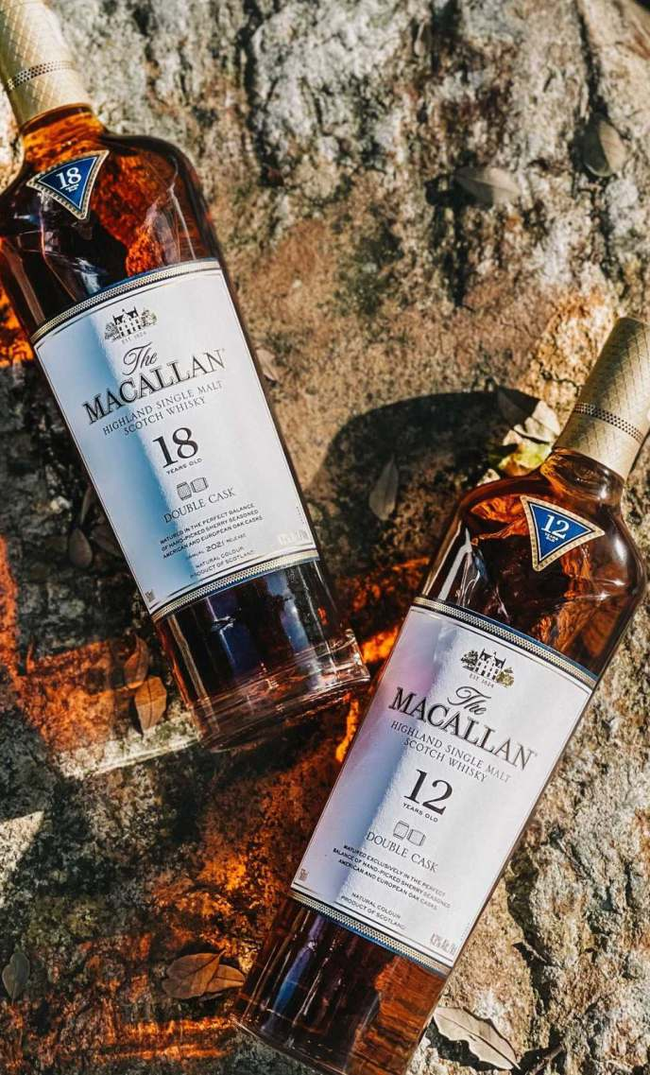



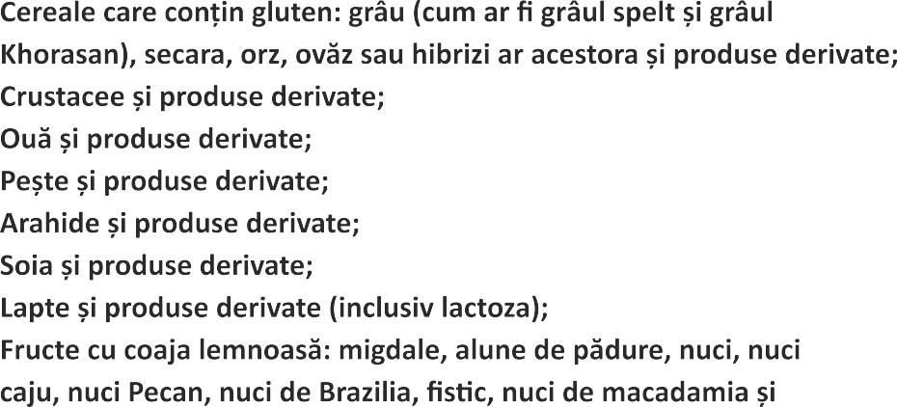
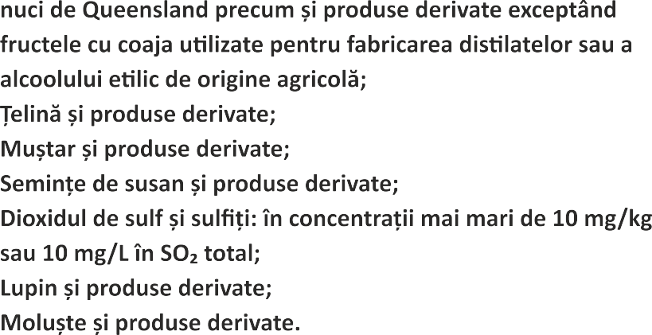

Business Hours:
MD-2012, Chişinău str. Mt. Bănulescu-Bodoni 22

Sun-Thu Fri-Sat
12:00 pm - 12:00 am
12:00 pm - 02:00 am

+373 (68) 89 20 89













































Churchillscigarshop@gmail.com
CHURCHILL'S WHISKY BAR CHURCHILLS_WHISKYBAR
WWW.CIGARCLUB.MD

